Mobile Sales Dashboard - User Guide

1. Introduction
This user guide provides a comprehensive overview of the Mobile Sales Dashboard. The dashboard enables users to monitor key sales metrics such as Total Sales Amount, Quantity Sold, Number of Transactions, and Customer Ratings across different cities, brands, and time periods.

2. Dashboard Overview
The Mobile Sales Dashboard consists of three main views, as shown in the figures below:
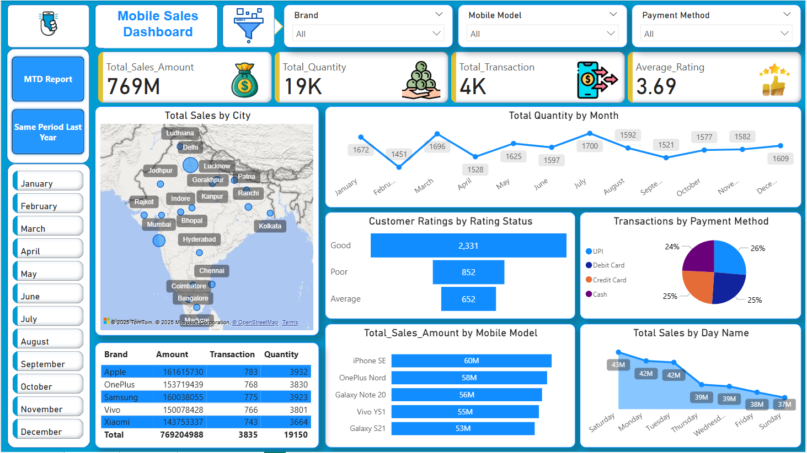
Figure 1: Main Dashboard View

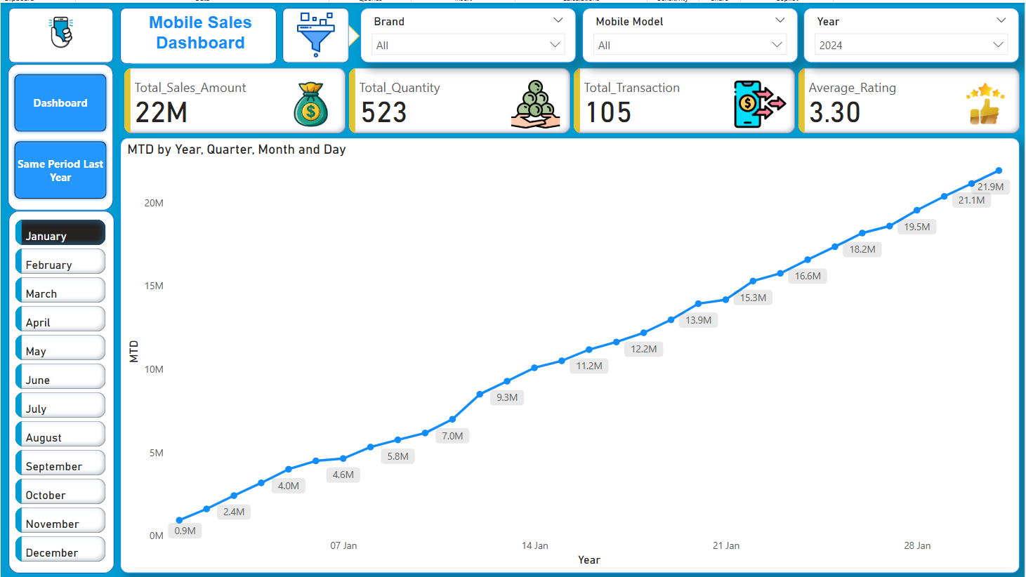
Figure 2: Month-to-Date (MTD) Report View

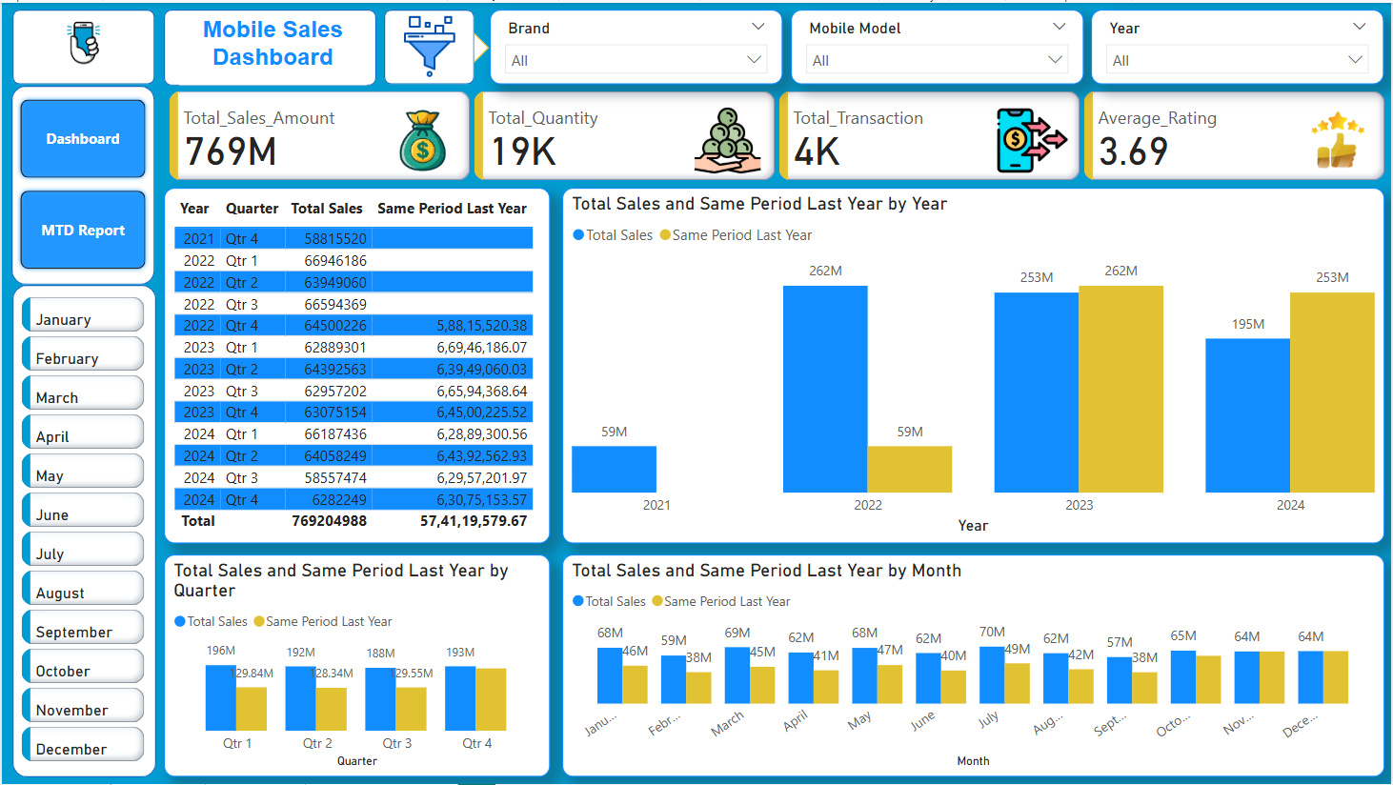
Figure 3: Same Period Last Year Comparison View

3. Key Metrics
- Total Sales Amount: Indicates the total revenue generated.
- Total Quantity: Number of units sold.
- Total Transaction: Number of purchase transactions completed.
- Average Rating: Average customer satisfaction rating.

4. Filters
Filters available at the top of the dashboard allow users to narrow down the data by Brand, Mobile Model, Payment Method, and Year.

5. Visual Components
- Sales by City: Geographic representation of sales volume by city.
- Quantity by Month: Line chart showing sales trends month over month.
- Ratings Distribution: Funnel chart of customer ratings.
- Payment Methods: Pie chart showing distribution of payment methods.
- Sales by Day: Line chart for total sales by day of the week.
- Sales by Brand & Model: Tables and bar charts summarizing brand/model performance.
- Yearly, Quarterly, and Monthly Comparisons: Comparison charts showing historical performance.
- Group Created : Group has been created for customer ratings to simplify.

6. Usage Tips
- Use filters to drill down into specific data views.
- Hover over visual elements for more detailed information.
- Compare performance with previous periods using the comparative charts.
- Can move from one page to another using ctrl + added button dashboard.

7. Dax Formula used
- Average_Rating = AVERAGE(Sales_Data[Customer Ratings])
- MTD = TOTALMTD([Total_Sales_Amount],Custom_Calendar[Date].[Date])
- Rating Status = IF(Sales_Data[Customer Ratings] >= 4,"Good", IF(Sales_Data[Customer Ratings] > 2, "Average", "Poor"))
- Sales_Amount = Sales_Data[Units Sold] * Sales_Data[Price Per Unit]
- Same Period Last Year = CALCULATE([Total_Sales_Amount], SAMEPERIODLASTYEAR(Custom_Calendar[Date].[Date]))
- Total_Quantity = SUM(Sales_Data[Units Sold])
- Total_Sales_Amount = SUMX(Sales_Data, Sales_Data[Units Sold]*Sales_Data[Price Per Unit])
- Total_Transaction = DISTINCTCOUNT(Sales_Data[Transaction ID])
- List.dates(#date(2021,1,1), 1461, #duration(1,0,0,0))

To extract content from excel file where we directly import folder in which multiple excel file stored.
- In power query editor click on binary content column and remove all other column.
- After add new custom column
Formula : =excel.workbook([content])
Click OK

